Site 29 District 1 Listing Price $69,000

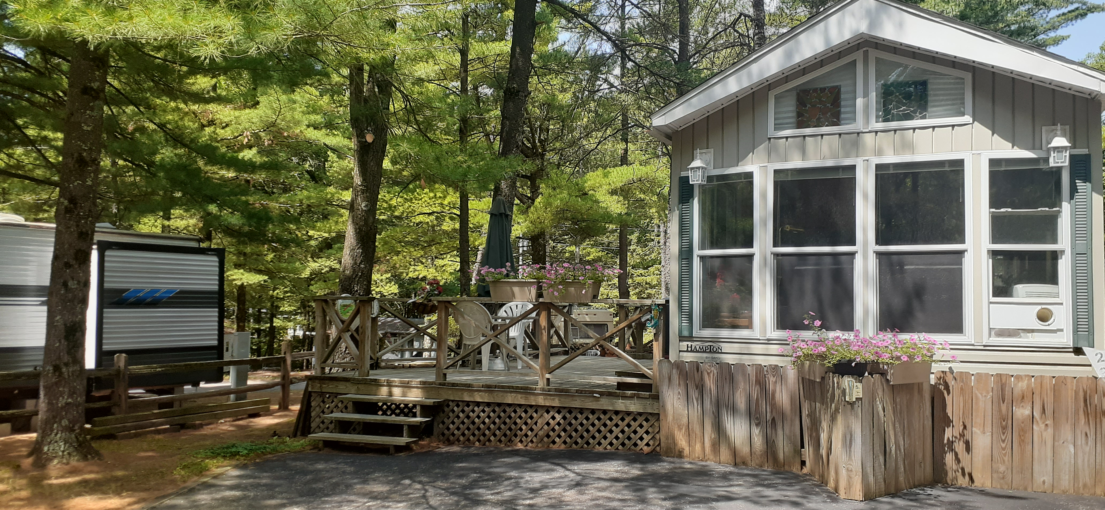 Site Improvements
_X_ Shed
__ Screen house Size: ________
_X_ Decking Size: 14’x22’
__ Add-a-room Size: ________
_X_ Skirting _X_ Asphalt Drive

Living Accommodations
_X_ Park Model__ Travel Trailer __ RV __ None
Brand: Sako/Hampton Year: 1999 Size: ______
Style: Double Loft Number of Bedrooms: 1
Sleeping accommodations: __ king _X_ queen __double __ twin __ bunk __ fold-out
Utilities + Appliances: _X_central A/C _X_ window A/C _X_stove _X_refrigerator _X_ microwave
Connections: _X_ telephone _X_ cable TV X electricity X sewer X water

Other Features: Well-insulated, metal bottom, new roof added 2021, refrigerator has ice maker, accessible year-round, close to clubhouse and pool, electric leather recliner

Exclusions: Personal items

